Welcome to
Trinity Lutheran Church
Lutheran Church—Missouri Synod
A Stephen Ministry Congregation

1354 South Otsego Avenue
Gaylord, Michigan 49735
Church Phone: (989) 732-4816

Church Email: secretary@trinitygaylord.com
www.trinitygaylord.com

Office Hours: Monday through Friday 9am – 1pm

OUR PURPOSE
…is to LOVE GOD, LOVE OTHERS, AND SERVE THE WORLD by worshiping the Lord Jesus, bringing our members into Christ-like maturity, and equipping them through Word and Sacrament for their mission and ministry. We go heart to heart into the world with Jesus, sharing His love, caring for one another, praying, and bringing the lost into a relationship with Christ, by the working of the Holy Spirit.

May 29, 2022
Seventh Sunday of Easter
Preacher: Rev. Paul Schneider

ABOUT OUR WORSHIP
We welcome all who gather here today! We are blessed to celebrate together the mercy, grace, and love we have from God through the death and resurrection of our Lord Jesus Christ.

Children: Families with children are very welcome here. Having children in church is important so they can begin to learn about their faith in Jesus, and it’s good for the whole congregation to see. Please feel comfortable keeping “squirmy” kids in the service. This is where they belong, too!

Pew Cards: Guests and Members, please fill out the Guest/Member card located on the back of the pew in front of you and pass it to the end of the aisle. If you forget you can put it in the offering plate on your way out.

If standing is difficult: Please feel free to remain seated during any portion of the service. Please let an Elder or Usher know if you need communion in your pew seat.

About our celebration of Holy Communion: We celebrate the Lord’s Supper in the confession and glad confidence that, as he says, our Lord gives into our mouths not only bread and wine but his very body and blood to eat and to drink for the forgiveness of sins and to strengthen our union with him and with one another. Our Lord invites to his table those who trust his words, repent of all sin, and set aside any refusal to forgive and love as he forgives and loves us, that they may show forth his death until he comes.

Because those who eat and drink our Lord’s body and blood contrary to that which is stated above do so to their great harm, and also because Holy Communion is a confession of the faith which is confessed at this altar. Anyone who is not yet instructed, in doubt, or who hold a confession differing from that of the Lutheran Church—Missouri Synod, and yet desire to receive the sacrament, are asked first to speak with Pastor. Those not communing are still invited to come forward for a blessing from Pastor, and you may indicate this by crossing your arms over your chest.
TTTTTT

GREETING
P Peace be with you.
C And also with you.
T ORDER OF SERVICE T
(The liturgy is from Divine Service Setting four LSB pg. 203ff)

OPENING HYMN
The Church’s One Foundation LSB 644
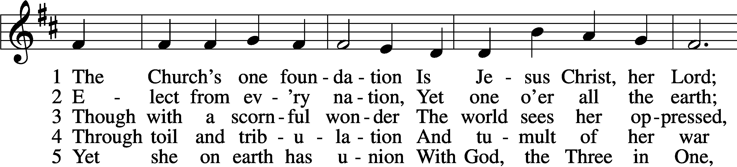
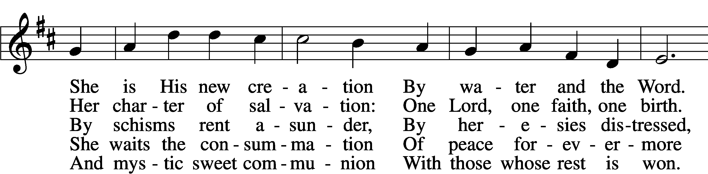
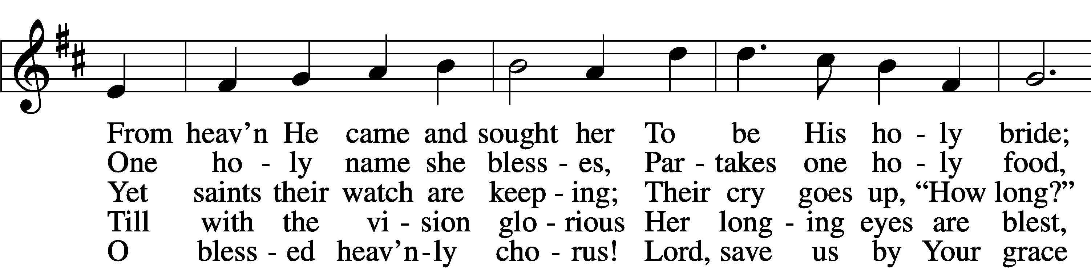
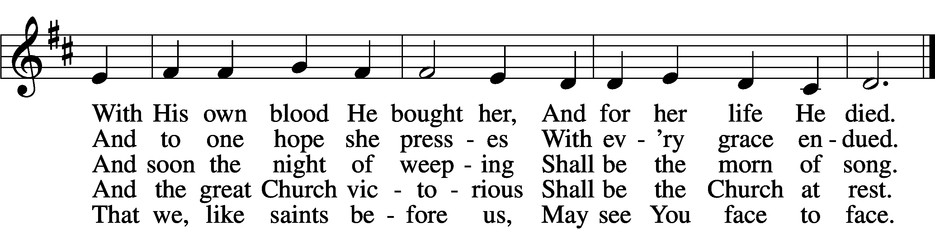
Text: Samuel J. Stone, 1839–1900, alt.
Tune: Samuel S. Wesley, 1810–76
Text and tune: Public domain

Please stand as able
CONFESSION and ABSOLUTION

The sign of the cross may be made by all in remembrance of their Baptism.

P In the name of the Father and of the T Son and of the Holy Spirit.
C Amen.
P Our help is in the name of the Lord,
C who made heaven and earth.
P If You, O Lord, kept a record of sins, O Lord, who could stand?
C But with You there is forgiveness; therefore, You are feared.
P Since we are gathered to hear God’s Word, call upon Him in prayer and praise, and receive the body and blood of our Lord Jesus Christ in the fellowship of this altar, let us first consider our unworthiness and confess before God and one another that we have sinned in thought, word, and deed, and that we cannot free ourselves from our sinful condition. Together as His people let us take refuge in the infinite mercy of God, our heavenly Father, seeking His grace for the sake of Christ, and saying: God, be merciful to me, a sinner.
C Almighty God, have mercy upon us, forgive us our sins, and lead us to everlasting life. Amen.
P Almighty God, merciful Father, in Holy Baptism You declared us to be Your children and gathered us into Your one, holy Church, in which You daily and richly forgive us our sins and grant us new life through Your Spirit. Be in our midst, enliven our faith, and graciously receive our prayer and praise; through Your Son, Jesus Christ, our Lord.
C Amen.

SERVICE OF THE WORD
KYRIE LSB 204
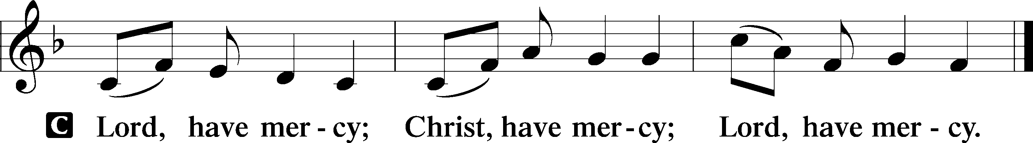
GLORIA IN EXCELSIS LSB 204
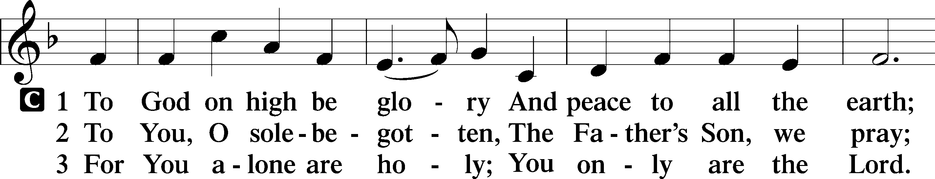
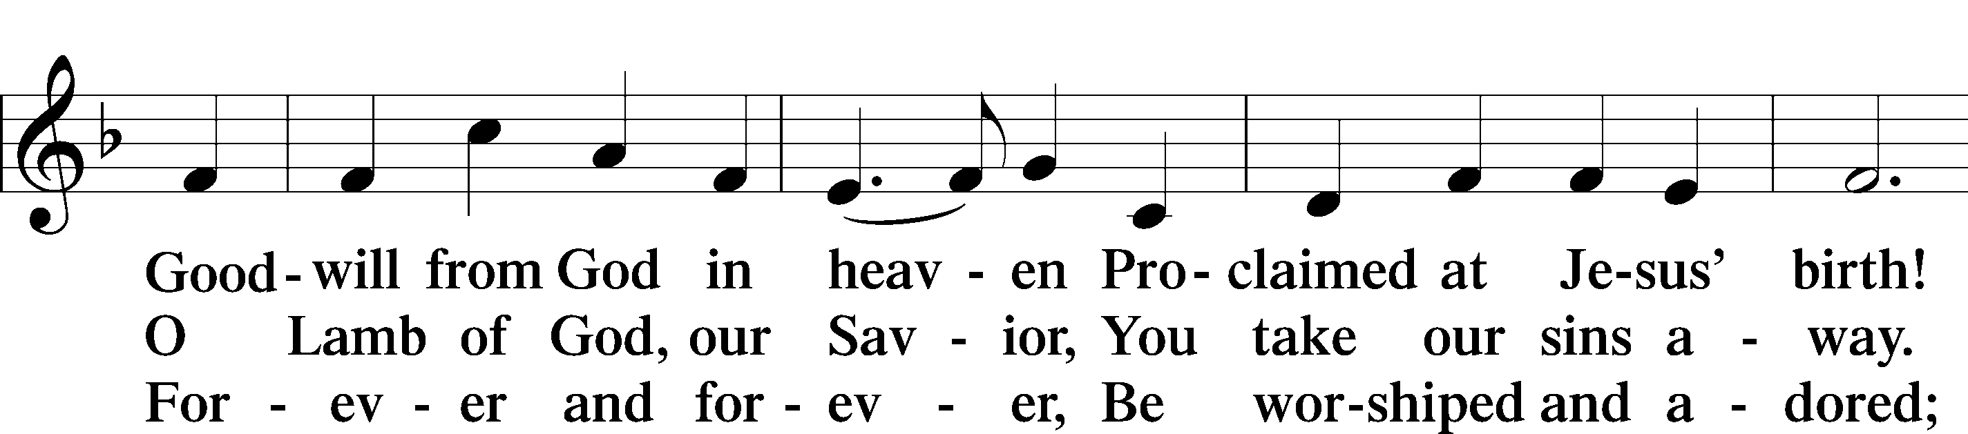
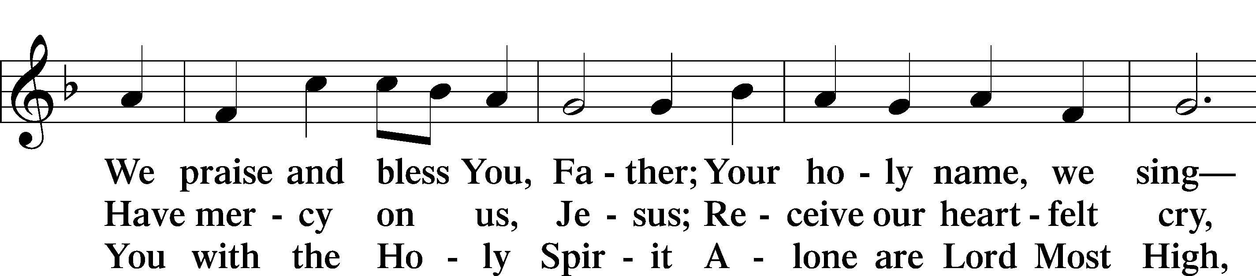
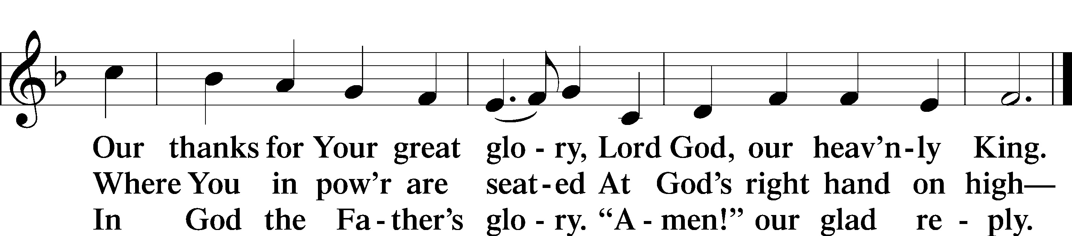
Text: Stephen P. Starke

SALUTATION AND COLLECT OF THE DAY
P The Lord be with you.
C And also with you.

P Let us pray.
O King of glory, Lord of hosts, uplifted in triumph far above all heavens, leave us not without consolation but send us the Spirit of truth whom You promised from the Father; for You live and reign with Him and the Holy Spirit, one God, now and forever.
C Amen.
Please be seated

FIRST READING Acts 1:12–26
¹²Then [the apostles] returned to Jerusalem from the mount called Olivet, which is near Jerusalem, a Sabbath day’s journey away. ¹³And when they had entered, they went up to the upper room, where they were staying, Peter and John and James and Andrew, Philip and Thomas, Bartholomew and Matthew, James the son of Alphaeus and Simon the Zealot and Judas the son of James. ¹⁴All these with one accord were devoting themselves to prayer, together with the women and Mary the mother of Jesus, and his brothers.
¹⁵In those days Peter stood up among the brothers (the company of persons was in all about 120) and said, ¹⁶“Brothers, the Scripture had to be fulfilled, which the Holy Spirit spoke beforehand by the mouth of David concerning Judas, who became a guide to those who arrested Jesus. ¹⁷For he was numbered among us and was allotted his share in this ministry.” ¹⁸(Now this man bought a field with the reward of his wickedness, and falling headlong he burst open in the middle and all his bowels gushed out. ¹⁹And it became known to all the inhabitants of Jerusalem, so that the field was called in their own language Akeldama, that is, Field of Blood.) ²⁰“For it is written in the Book of Psalms,
“‘May his camp become desolate,
and let there be no one to dwell in it’; and
“‘Let another take his office.’
²¹So one of the men who have accompanied us during all the time that the Lord Jesus went in and out among us, ²²beginning from the baptism of John until the day when he was taken up from us—one of these men must become with us a witness to his resurrection.” ²³And they put forward two, Joseph called Barsabbas, who was also called Justus, and Matthias. ²⁴And they prayed and said, “You, Lord, who know the hearts of all, show which one of these two you have chosen ²⁵to take the place in this ministry and apostleship from which Judas turned aside to go to his own place.” ²⁶And they cast lots for them, and the lot fell on Matthias, and he was numbered with the eleven apostles.

P This is the Word of the Lord.
C Thanks be to God.

EPISTLE Revelation 22
¹Then the angel showed me the river of the water of life, bright as crystal, flowing from the throne of God and of the Lamb ²through the middle of the street of the city; also, on either side of the river, the tree of life with its twelve kinds of fruit, yielding its fruit each month. The leaves of the tree were for the healing of the nations. ³No longer will there be anything accursed, but the throne of God and of the Lamb will be in it, and his servants will worship him. ⁴They will see his face, and his name will be on their foreheads. ⁵And night will be no more. They will need no light of lamp or sun, for the Lord God will be their light, and they will reign forever and ever.
⁶And he said to me, “These words are trustworthy and true. And the Lord, the God of the spirits of the prophets, has sent his angel to show his servants what must soon take place.”
⁷“And behold, I am coming soon. Blessed is the one who keeps the words of the prophecy of this book.”
⁸I, John, am the one who heard and saw these things. And when I heard and saw them, I fell down to worship at the feet of the angel who showed them to me, ⁹but he said to me, “You must not do that! I am a fellow servant with you and your brothers the prophets, and with those who keep the words of this book. Worship God.”
¹⁰And he said to me, “Do not seal up the words of the prophecy of this book, for the time is near. ¹¹Let the evildoer still do evil, and the filthy still be filthy, and the righteous still do right, and the holy still be holy.”
¹²“Behold, I am coming soon, bringing my recompense with me, to repay everyone for what he has done. ¹³I am the Alpha and the Omega, the first and the last, the beginning and the end.”
¹⁴Blessed are those who wash their robes, so that they may have the right to the tree of life and that they may enter the city by the gates. ¹⁵Outside are the dogs and sorcerers and the sexually immoral and murderers and idolaters, and everyone who loves and practices falsehood.
¹⁶“I, Jesus, have sent my angel to testify to you about these things for the churches. I am the root and the descendant of David, the bright morning star.”
¹⁷The Spirit and the Bride say, “Come.” And let the one who hears say, “Come.” And let the one who is thirsty come; let the one who desires take the water of life without price.
¹⁸I warn everyone who hears the words of the prophecy of this book: if anyone adds to them, God will add to him the plagues described in this book, ¹⁹and if anyone takes away from the words of the book of this prophecy, God will take away his share in the tree of life and in the holy city, which are described in this book.
²⁰He who testifies to these things says, “Surely I am coming soon.” Amen. Come, Lord Jesus!
²¹The grace of the Lord Jesus be with all. Amen.

P This is the Word of the Lord.
C Thanks be to God.

Please stand as able

ALLELUIA AND VERSE LSB 205
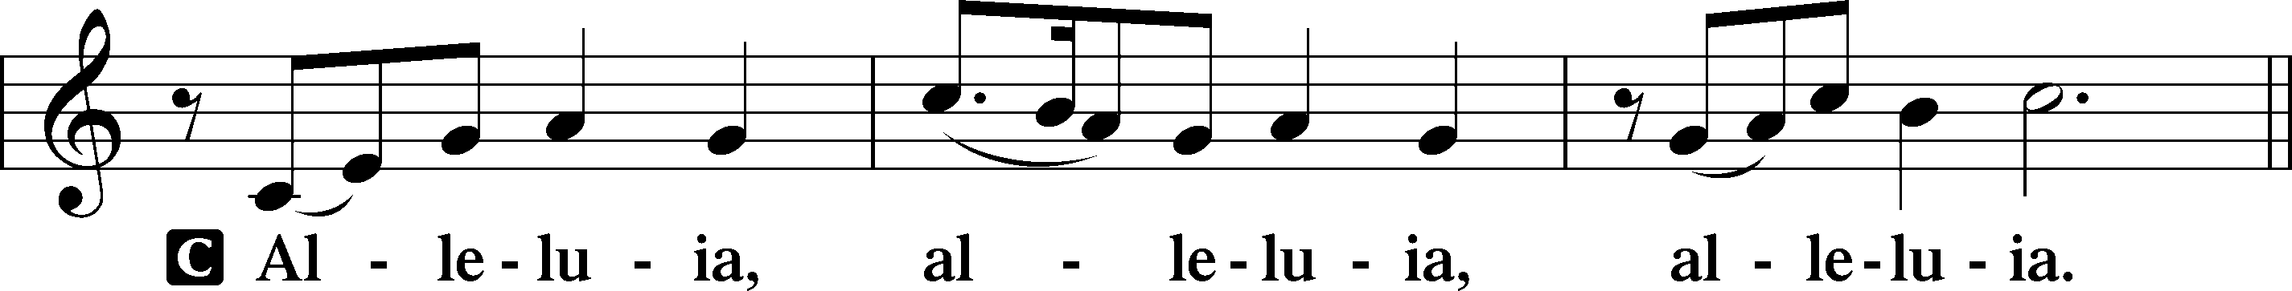

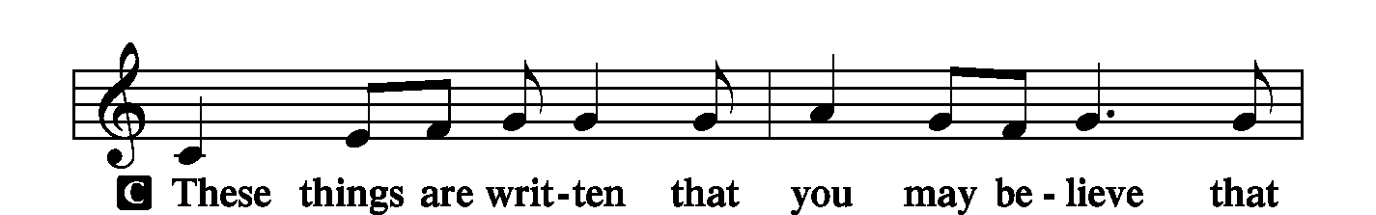
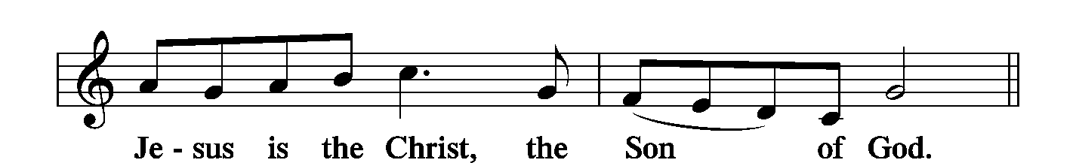
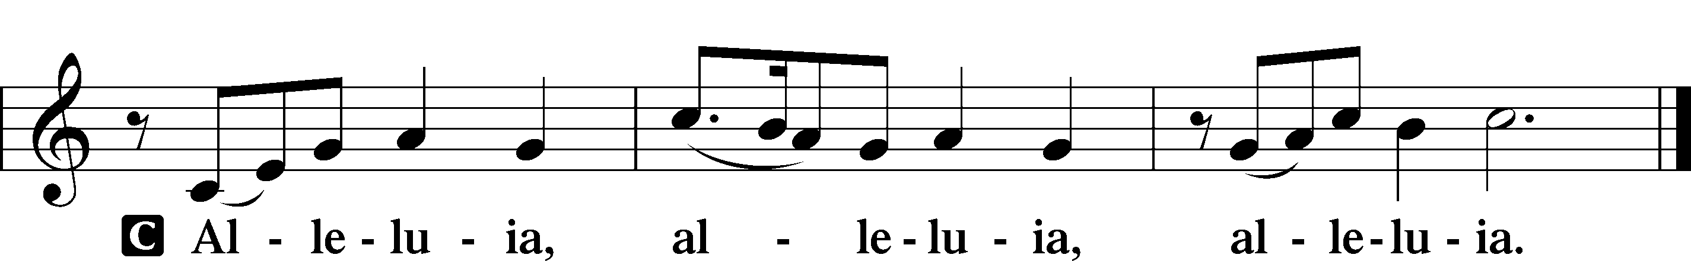

HOLY GOSPEL John 17:20–26
P The Holy Gospel according to St. John, the seventeenth chapter.
C Glory to You, O Lord.
²⁰[Jesus said:] “I do not ask for these only, but also for those who will believe in me through their word, ²¹that they may all be one, just as you, Father, are in me, and I in you, that they also may be in us, so that the world may believe that you have sent me. ²²The glory that you have given me I have given to them, that they may be one even as we are one, ²³I in them and you in me, that they may become perfectly one, so that the world may know that you sent me and loved them even as you loved me. ²⁴Father, I desire that they also, whom you have given me, may be with me where I am, to see my glory that you have given me because you loved me before the foundation of the world. ²⁵O righteous Father, even though the world does not know you, I know you, and these know that you have sent me. ²⁶I made known to them your name, and I will continue to make it known, that the love with which you have loved me may be in them, and I in them.”
P This is the Gospel of the Lord.
C Praise to You, O Christ.
NICENE CREED
C I believe in one God,
the Father Almighty,
maker of heaven and earth
and of all things visible and invisible.
And in one Lord Jesus Christ,
the only-begotten Son of God,
begotten of His Father before all worlds,
God of God, Light of Light,
very God of very God,
begotten, not made,
being of one substance with the Father,
by whom all things were made;
who for us men and for our salvation came down from heaven
and was incarnate by the Holy Spirit of the virgin Mary
and was made man;
and was crucified also for us under Pontius Pilate.
He suffered and was buried.
And the third day He rose again according to the Scriptures
and ascended into heaven
and sits at the right hand of the Father.
And He will come again with glory to judge both the living and the dead,
whose kingdom will have no end.
And I believe in the Holy Spirit,
the Lord and giver of life,
who proceeds from the Father and the Son,
who with the Father and the Son together is worshiped and glorified,
who spoke by the prophets.
And I believe in one holy Christian and apostolic Church,
I acknowledge one Baptism for the remission of sins,
and I look for the resurrection of the dead
and the life T of the world to come. Amen.

Please be seated

“ALL GOD’S CHILDREN” TALK
PRE SERMON HYMN
The Saints in Christ Are One in Every Place LSB 838 sts. 1–2
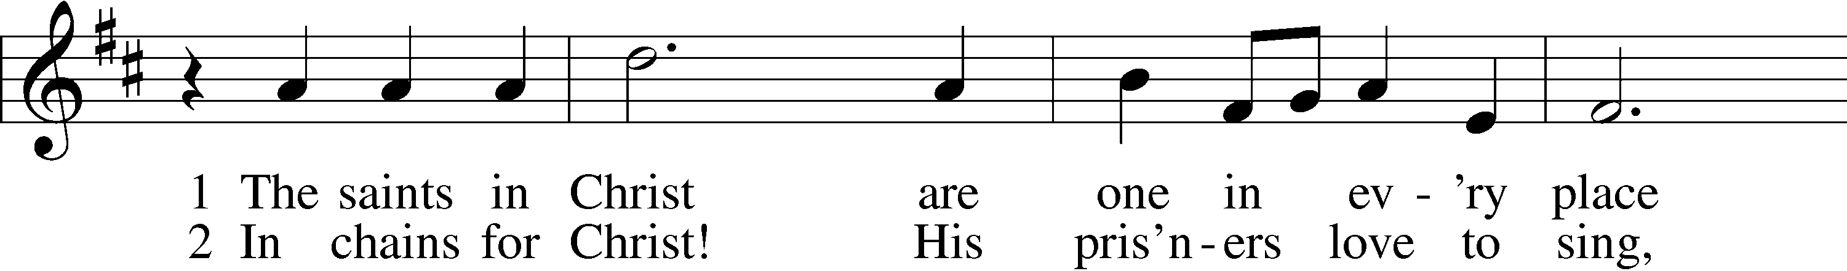
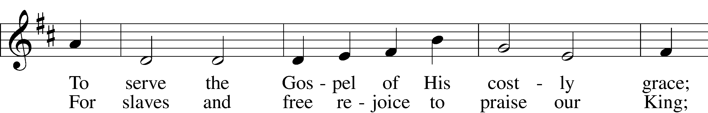
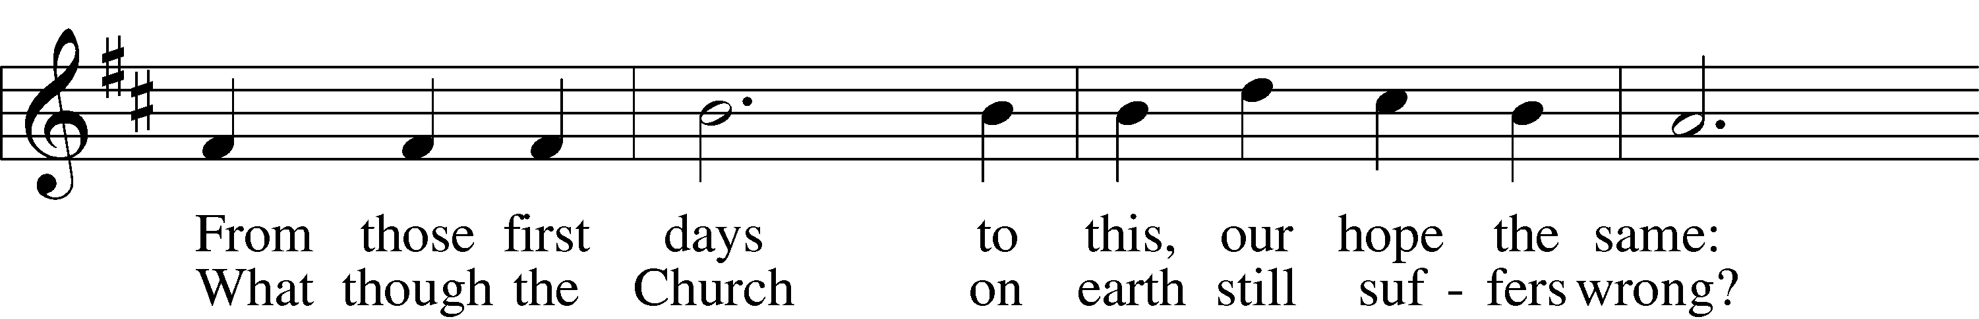
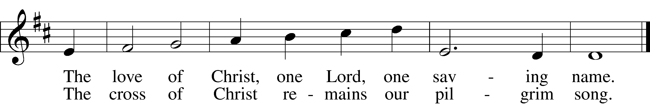
Text: Christopher M. Idle, 1938, alt.
Tune: Walter Greatorex, 1877–1949
Text: © 1996 The Jubilate Group, admin. Hope Publishing Co. Used by permission: LSB Hymn License no. 110002537
Tune: © Oxford University Press. Used by permission: LSB Hymn License no. 110002537

SERMON
POST SERMON HYMN
The Saints in Christ Are One in Every Place LSB 838 sts. 3–4
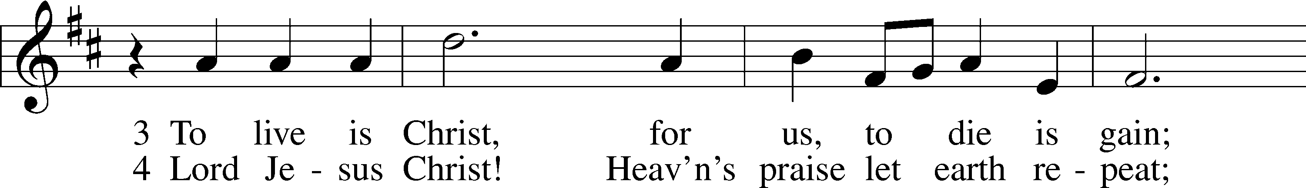
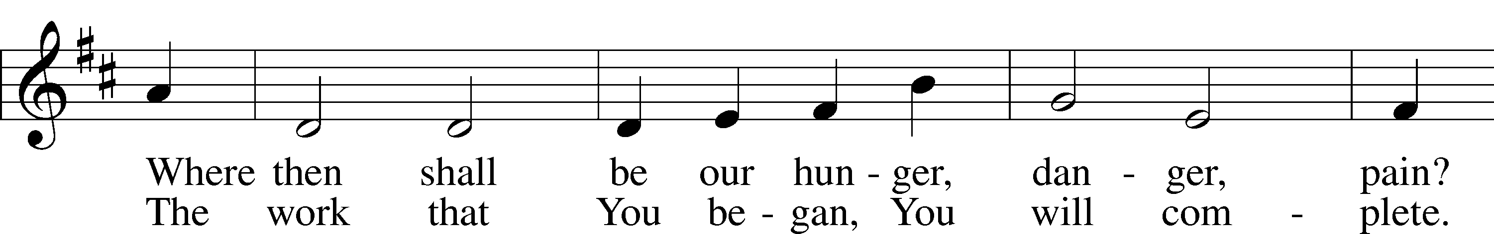
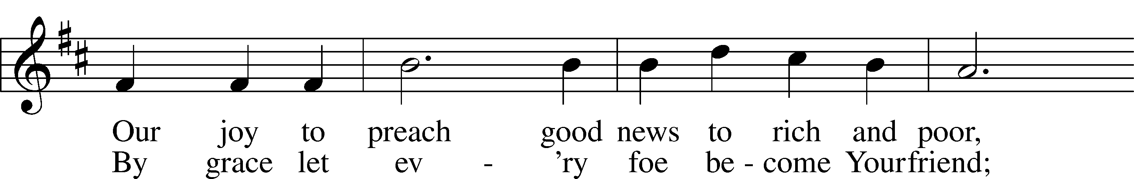
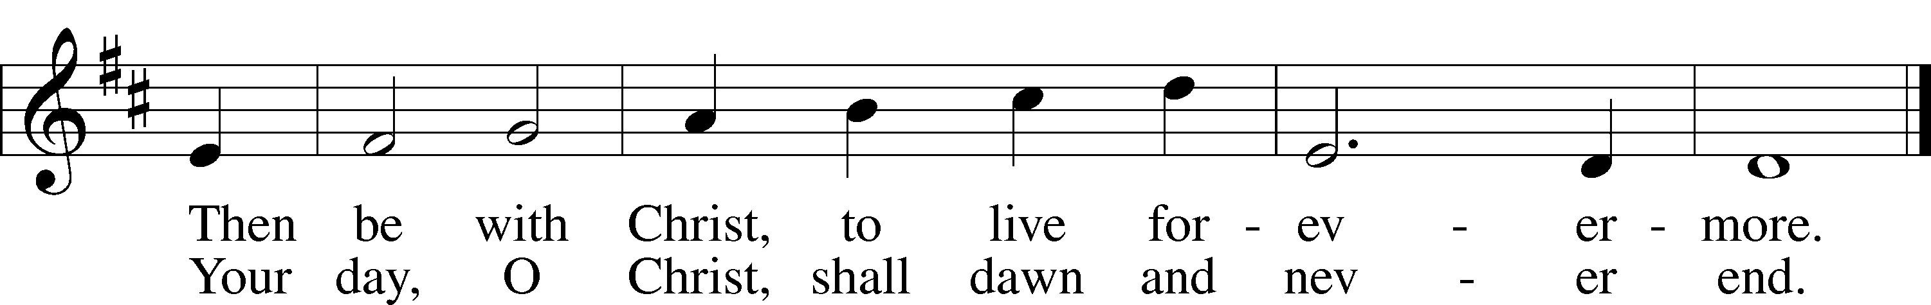
Text: Christopher M. Idle, 1938, alt.
Tune: Walter Greatorex, 1877–1949
Text: © 1996 The Jubilate Group, admin. Hope Publishing Co. Used by permission: LSB Hymn License no. 110002537
Tune: © Oxford University Press. Used by permission: LSB Hymn License no. 110002537

PRAYER of the CHURCH
After each Segment:
P Lord, in Your Mercy,
C Hear our Prayer.
After Final Segment:
P Hear us as we pray in His name and as He has taught us:

LORD’S PRAYER
Our Father, Who art in heaven, hallowed be Thy name,
Thy kingdom come, Thy will be done, on earth as it is in heaven.
Give us this day our daily bread;
and forgive us our trespasses, as we forgive those who trespass against us;
and lead us not into temptation,
but deliver us from evil.
For Thine is the kingdom, and the power, and the glory, forever and ever. Amen.

SERVICE of the SACRAMENT
Please stand as able
PREFACE LSB 208
P The Lord be with you.
C And also with you.
P Lift up your hearts.
C We lift them to the Lord.

P Let us give thanks to the Lord our God.
C It is right to give Him thanks and praise.

P It is truly good, right, and salutary that we should at all times and in all places give thanks to you, holy Lord, almighty Father, everlasting God, Through Jesus Christ our Lord, who ascended above the heavens and, sitting at your right hand, poured out on this day as He had promised the Holy Spirit on the Chosen disciples. At At this the whole earth rejoices with exceeding joy.
Therefore with angels and archangels and with all the company of heaven we laud and magnify Your glorious name, evermore praising You and singing:

SANCTUS LSB 208
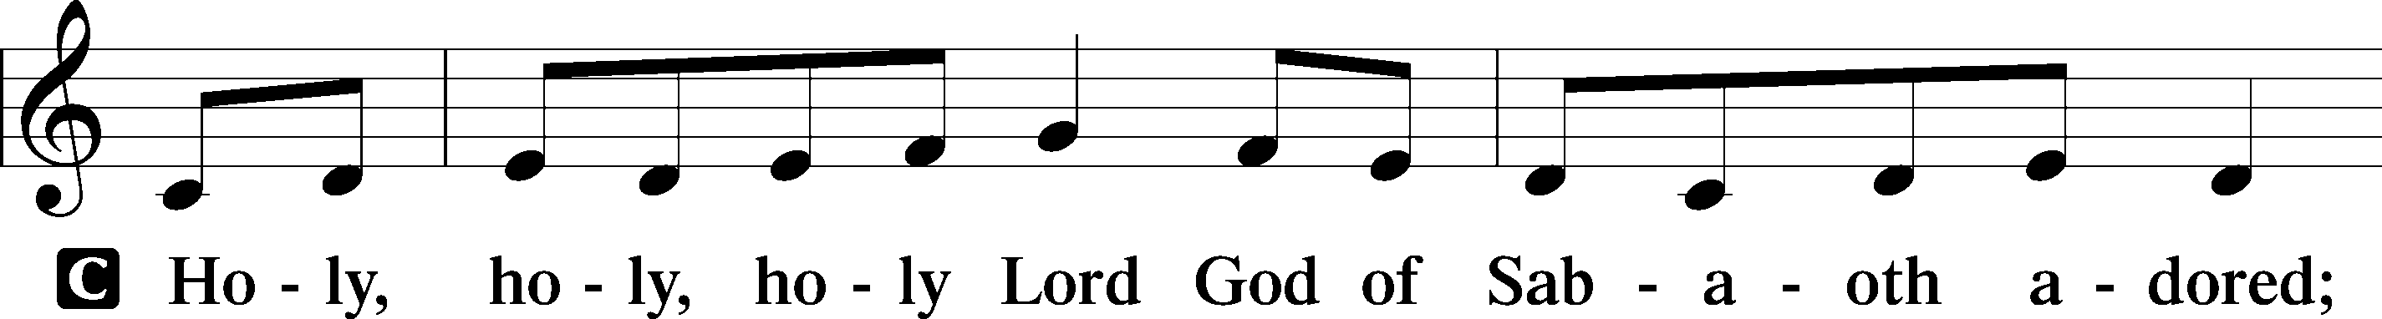
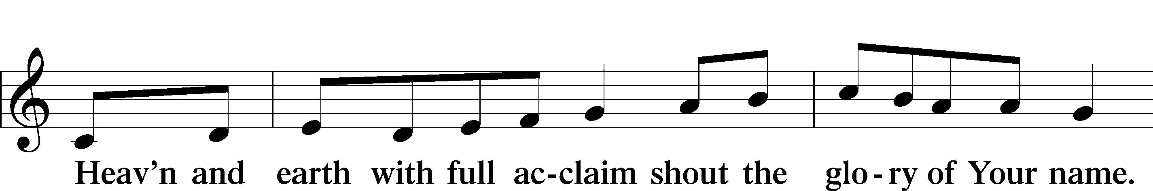
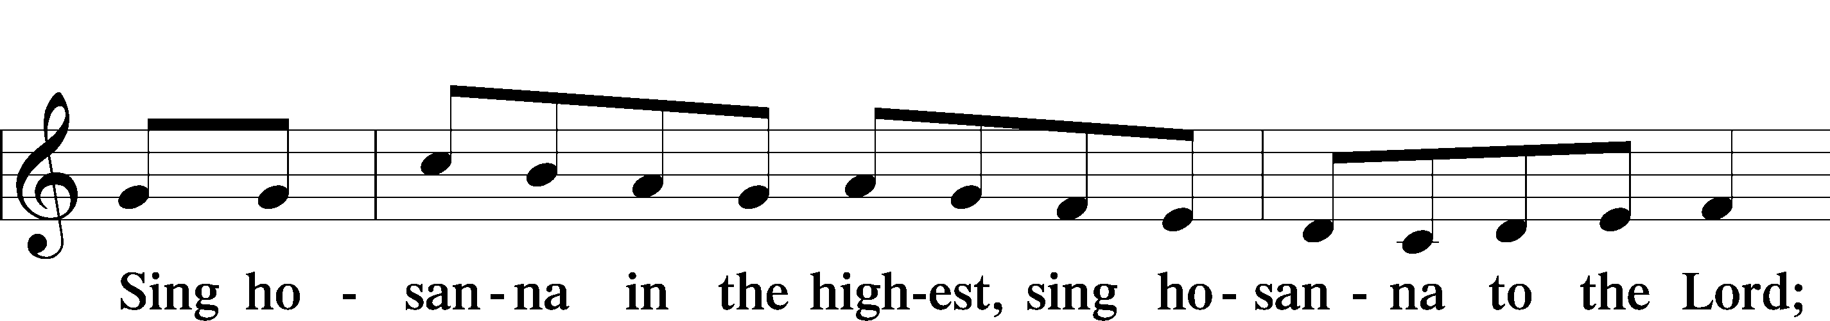

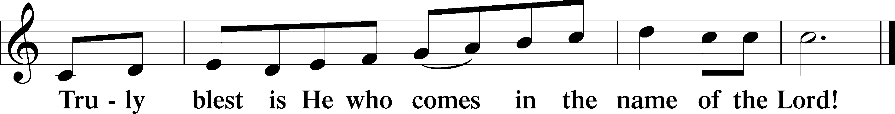
THE WORDS OF OUR LORD
P Our Lord Jesus Christ, on the night when He was betrayed, took bread, and when He had given thanks, He broke it and gave it to the disciples and said: “Take, eat; this is My T body, which is given for you. This do in remembrance of Me.”
In the same way also, He took the cup after supper, and when He had given thanks, He gave it to them, saying: “Drink of it, all of you; this cup is the New Testament in My T blood, which is shed for you for the forgiveness of sins. This do, as often as you drink it, in remembrance of Me.”

PAX DOMINI
P The peace of the Lord be with you always.
C Amen.
AGNUS DEI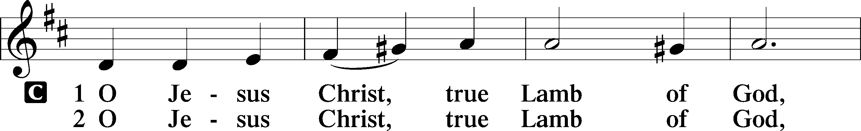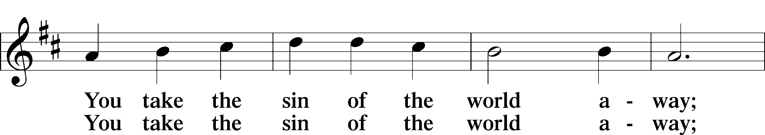
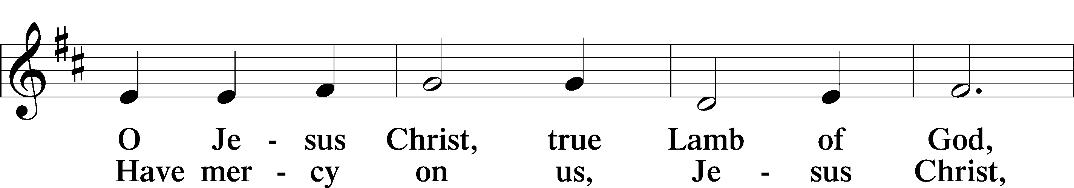
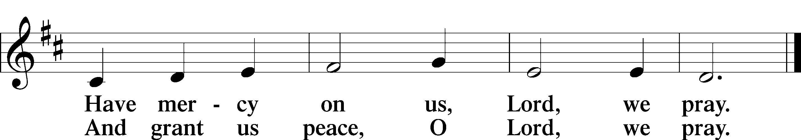
Please be seated

DISTRIBUTION
The pastor and those who assist him receive the body and blood of Christ first, then Communion will be served at the rail.. Ushers will help direct you forward via the center aisle; please return to your seats via the side aisles. Gluten-free bread is available for those who need it, as is non-alcoholic grape juice. Simply request either when you come forward to receive Communion.

DISTRIBUTION HYMN
O Lord, We Praise Thee LSB 617
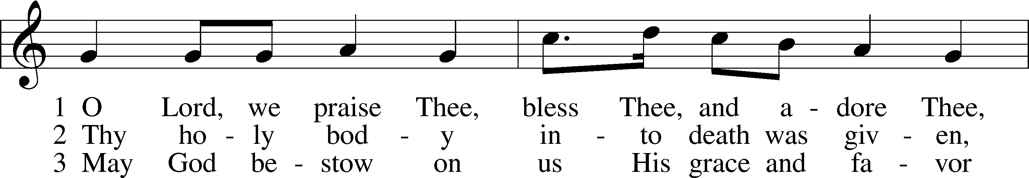
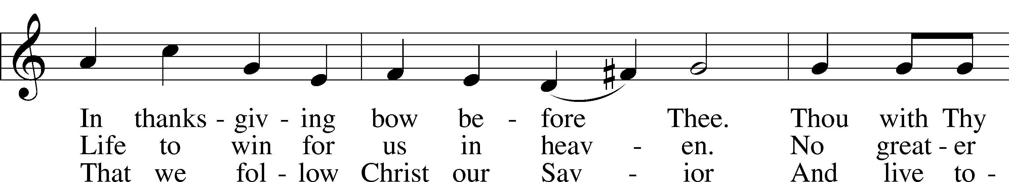
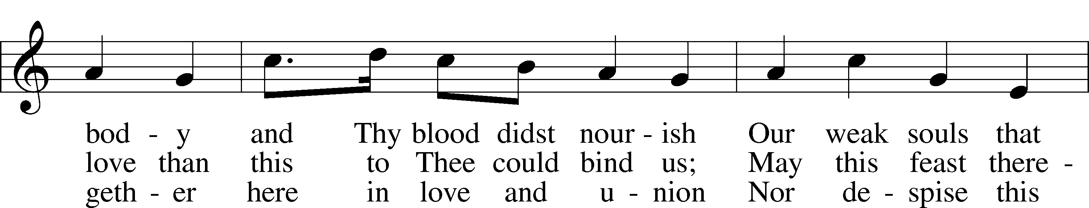
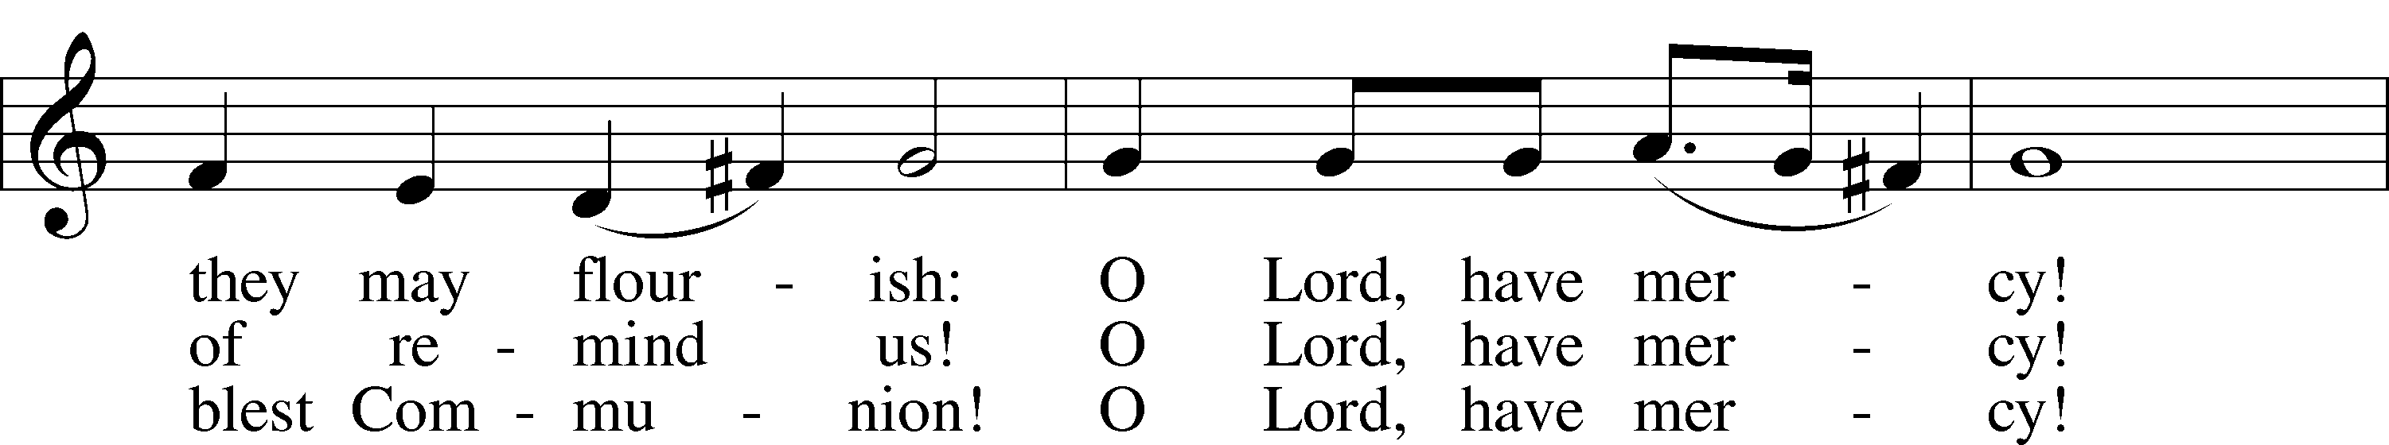
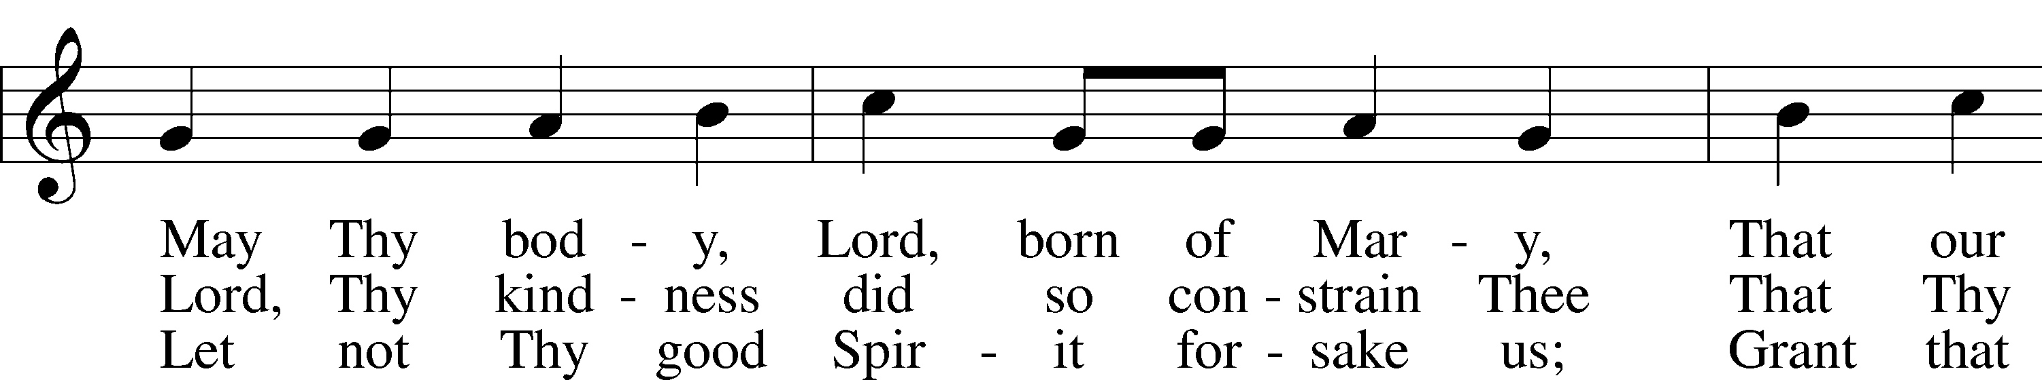
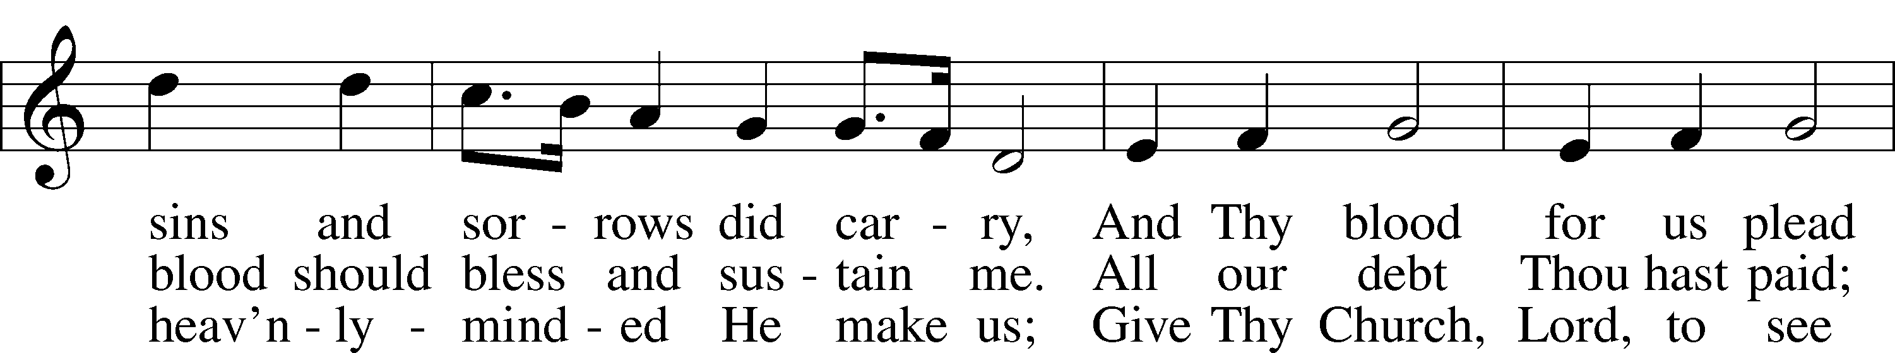
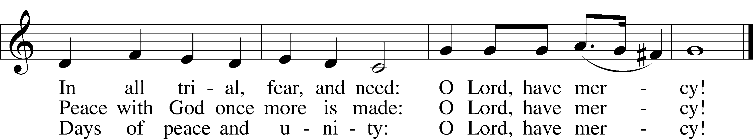

Please stand as able

NUNC DIMITTIS LSB 211
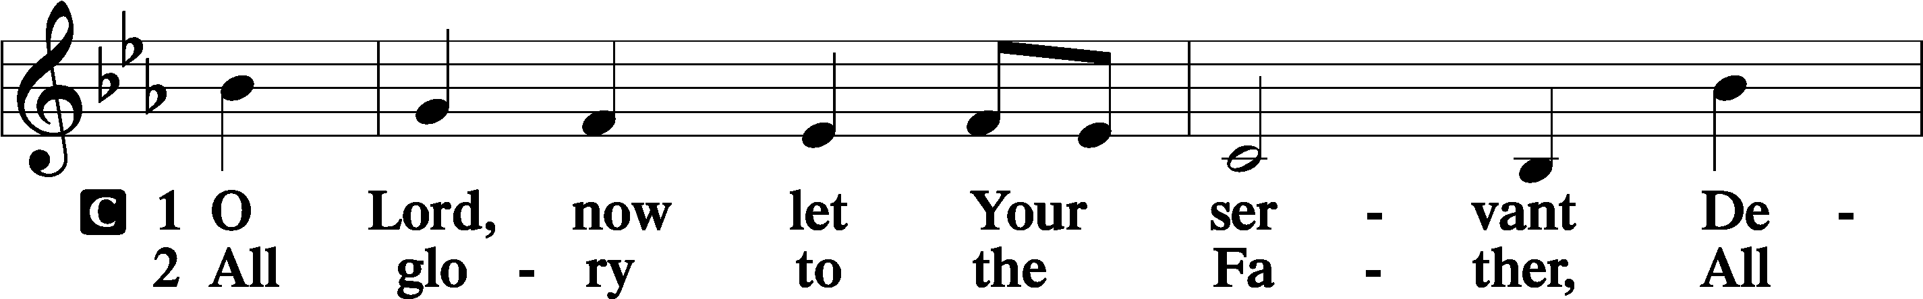
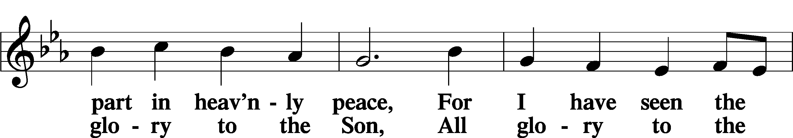
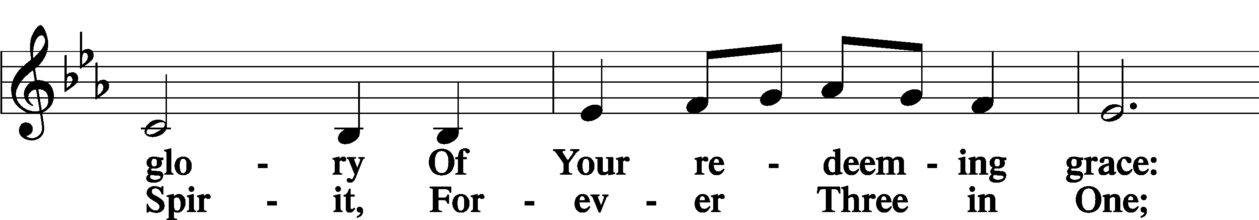
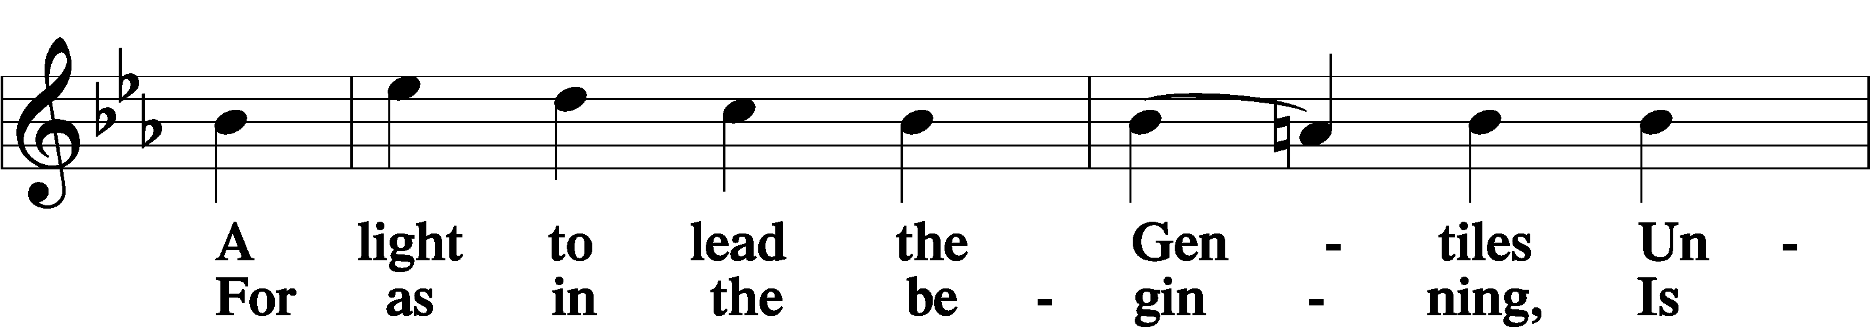
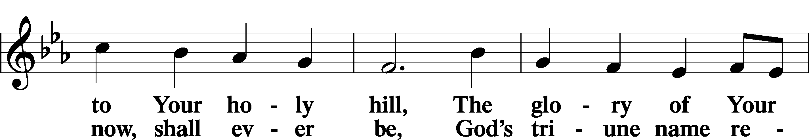
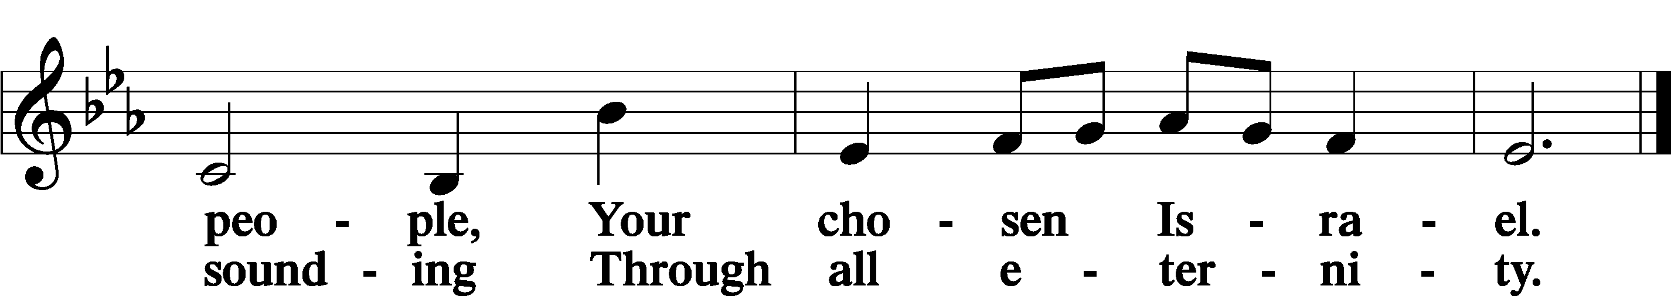
POST COMMUNION COLLECT
P Let us pray.
O God the Father, the fountain and source of all goodness, who in loving-kindness sent Your only-begotten Son into the flesh, we thank You that for His sake You have given us pardon and peace in this Sacrament, and we ask You not to forsake Your children but always to rule our hearts and minds by Your Holy Spirit that we may be enabled constantly to serve You; through Jesus Christ, Your Son, our Lord, who lives and reigns with You and the Holy Spirit, one God, now and forever.
C Amen.

BENEDICAMUS LSB 212
P Let us bless the Lord.
C Thanks be to God.
BENEDICTION
P The Lord bless you and keep you.
The Lord make His face shine on you and be gracious to you.
The Lord look upon you with favor and T give you peace.
C Amen.

Please be seated

CLOSING HYMN
Want to Walk as a Child of the Light LSB 411
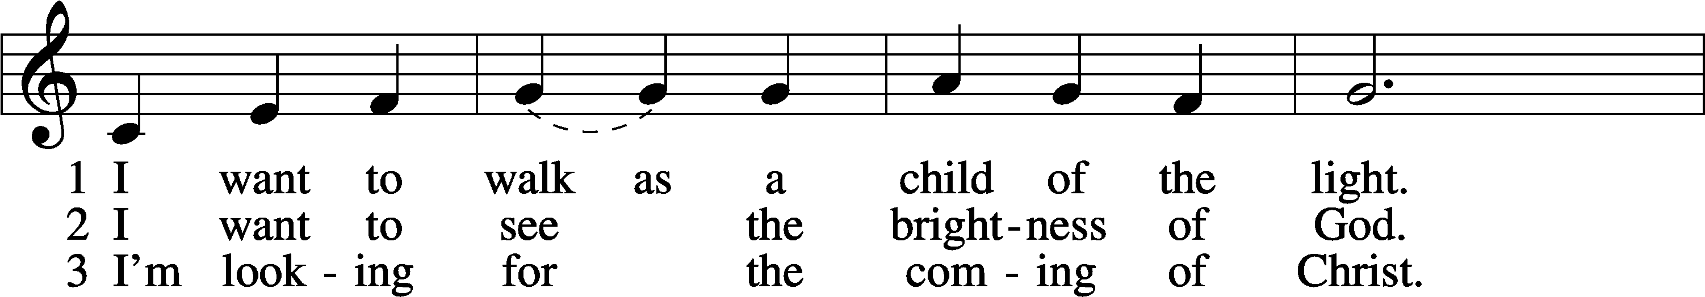
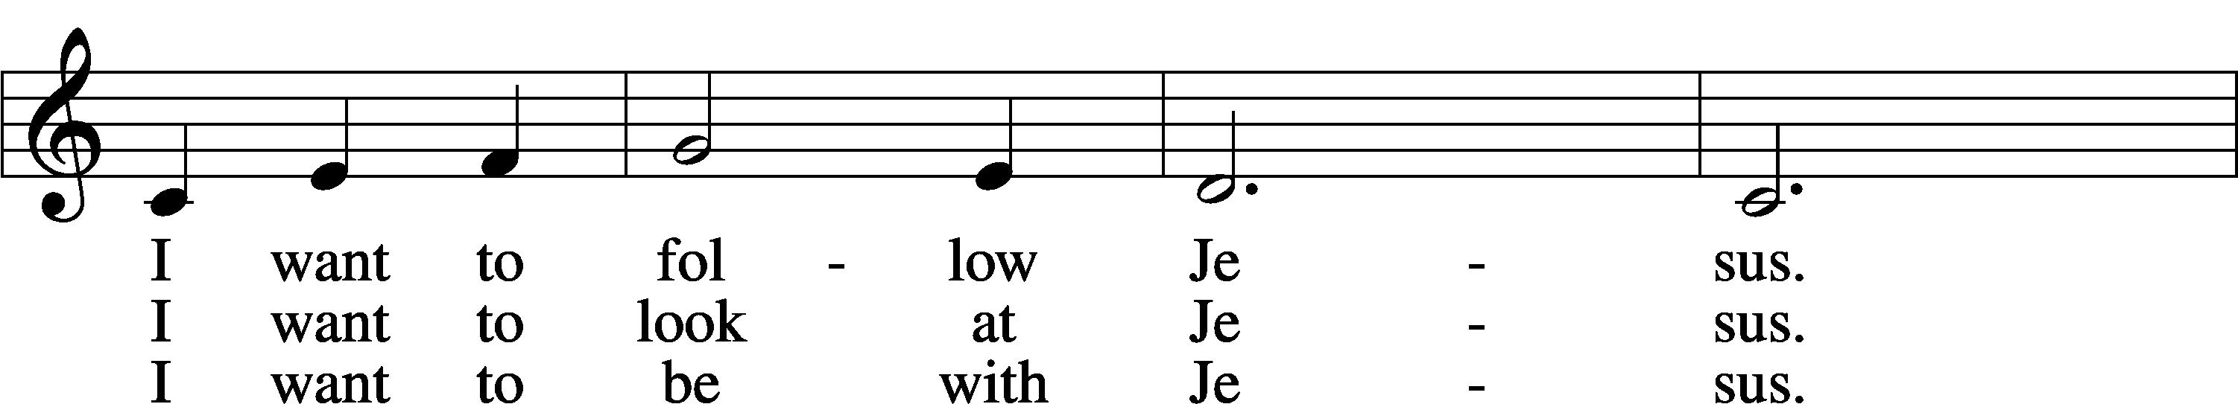
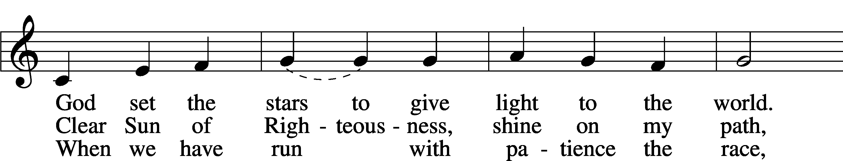
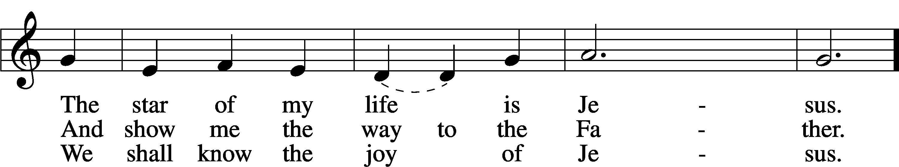
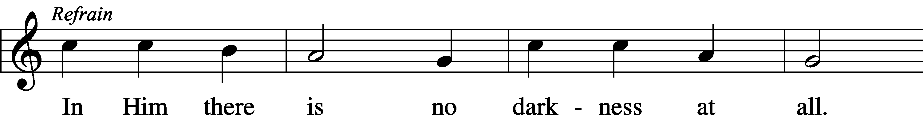
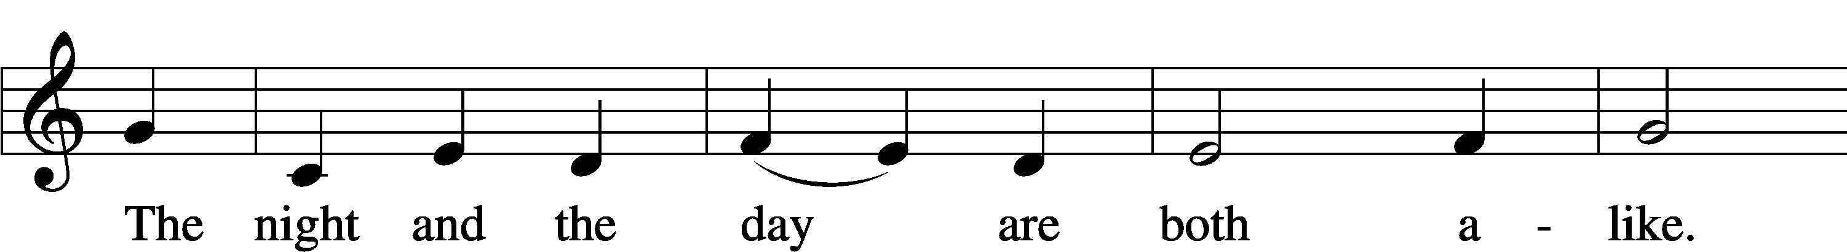
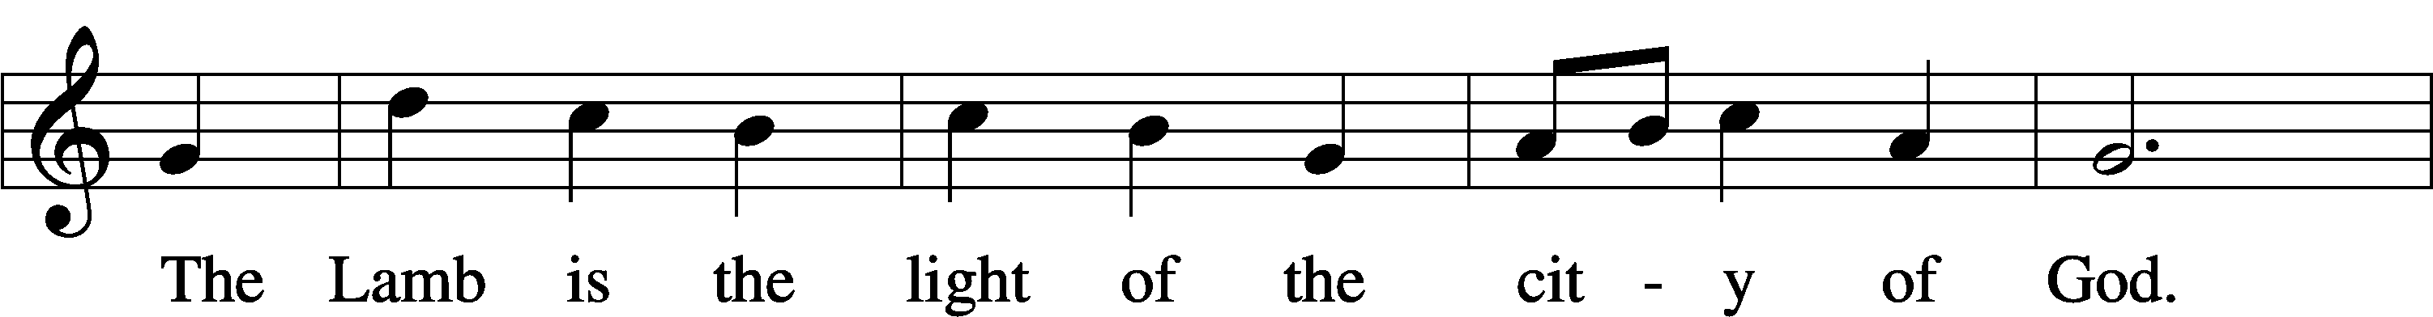
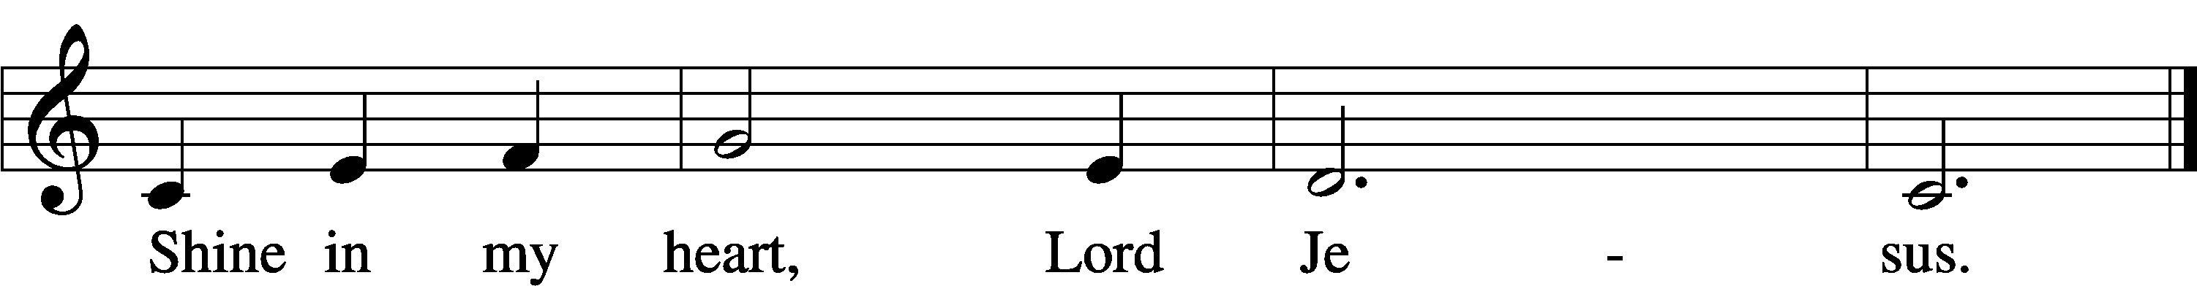
Text and tune: Kathleen Thomerson, 1934Text and tune: © 1970, 1975 Celebration. Used by permission: LSB Hymn License no. 110002537

ANNOUNCEMENTS and SENDING WORDS
P We go to live for Jesus!
C We go to share His love!

Acknowledgments
Unless otherwise indicated, Scripture quotations are from the ESV® Bible (The Holy Bible, English Standard Version®), copyright © 2001 by Crossway, a publishing ministry of Good News Publishers. Used by permission. All rights reserved. Created by Lutheran Service Builder© Concordia Publishing House.

NEXT WEEKS READINGS
First Reading: Genesis 11:1-9
Epistle: Acts 2:1-21
Holy Gospel: John 14:23-31

SERVING in GODS HOUSE TODAY
Pastor: Rev. Paul Schneider
Elder: Ken Mertz
Ushers: Jim & Marge Kunisch
Greeters: John & Judi Stutzman
Coffee: Kunisch
Counters: Larry Whitney, Wendell Smith
Altar Care: Judi Stutzman
Virtual Organist: Bob Erat
PRAYERS
Please contact the office with updates to the prayer list. People will remain on the prayer list for 4 weeks before being removed. If they need to remain on the list, please keep Elaine informed and of any updates. This will help us to have a more accurate list. Thanks for your cooperation.

Those who continue to grieve the passing of loved ones, The Family of Karen Christoff, and the family of Ruth Luebs.
Those with upcoming surgery:
Those recovering from surgery: Tanner Beyers, Sasha (Rose Dittmans Grandson), Jennifer Martin, and Ron Kwapis.
Those with health concerns: Tiffany Amsdill, Laurie Breen, Hope Buchinger, Betsy Cook Kay Gregg, Hilda Koch, Eleanor Raether, Beth Smith, Judi Stutzman, and Joann Whitney.
Those diagnosed with cancer: Leah Eicher, Maria Freimark, Rachel Frisch, Joe Gibson, Janice Knoellinger, Leslie Martin, Brian Morgan, Hope Osantowski,, Ken Radke, and John Stutzman.
Those under Hospice Home Care: Ken Williamson.

BIRTHDAYS:
6/1 Noah Smith
6/4 Andrew Albrecht
6/4 Carla Elenz

ANNIVERSARIES;
Glenn & Elizabeth Smith

MESSAGES
ALTAR FLOWERS this week were given to the Glory of God from all Gods Children.
OUTREACH PICNIC COMMITTEE MEETING: We are starting up again with our annual church picnic (This is not a dual parish picnic). Picnic is July24th. This is the first meeting on putting together our church picnic. We will be meeting in the fellowship hall. If you are interested in being part of this committee please sign up on the sheet on the board in the narthex. If you do not sign up you can still come to the meeting and see if there is anything you would like to help with. We can use all the help we can get on planning this picnic it is the first one since covid.
MEMBER & GUEST CARDS: If you have not filled out a member/guest card, please take the time to fill one out and place it in the plate behind the back pews in our sanctuary.

WEDNESDAY MORNING BIBLE STUDY will be taking a break for the summer and will resume sometime in September.

LWML SUMMER POP-UP CRAFT SALES: LWML plans to have occasional mini craft sales this summer. With short notice we will set up a few canopies in the front yard and offer our crafts for sale, with the profits designated for missions, both locally and throughout the world. Dates have yet to be determined. So, crafters, please get thinking about what handmade items you can prepare in advance for us to sell. We welcome and appreciate your donations.

ALTAR FLOWERS: There are still spots open for Altar flowers, if you have birthdays, anniversaries, new baby or in memory of someone, or just for something special like dressing up the Altar. The signup sheet is in the fellowship hall as you go in the door. Flowers are $30.00 for the two flowers. Order them, they will be put on the altar, after the service then take them home to enjoy.

THIS WEEK AT TRINITY
May29 Sunday
9:00 am Worship Service - Holy Communion – Rev. Paul Schneider
10:00 am Fellowship & Coffee Hour
10:30 am Bible Study with Dr. Tom Beach (Tutoring Room)
May 30 Monday
7:00 pm Choir
May 31 Tuesday
June 1 Wednesday
1:00 pm Outreach Picnic Committee meeting
June 2 Thursday
June 3 Friday
June 4 Saturday
10:00 am Stephen Ministry Peer Support Group Meeting
June 5 Sunday
9:00 am Worship Service - Holy Communion – Rev. Paul Schneider
10:00 am Fellowship & Coffee Hour
10:30 am Bible Study with Dr. Tom Beach (Tutoring Room)

